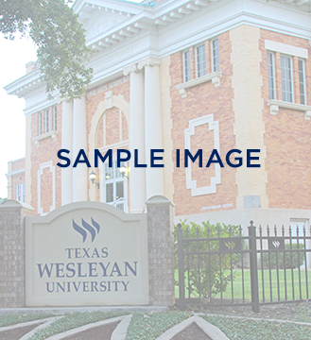

txwes.edu

vvvvvvve

Event details  
August 21  
3:00 p.m. – 5:00 p.m.  
Location

More event details could go here if needed. More event details could go here if needed. More event details could go here if needed. More event details could go here if needed. More event details could go here if needed.

Sample Title Here

Sample Info Line here

1201 Wesleyan Street | Fort Worth, Texas 76105   
817-531-4444 | info@txwes.edu