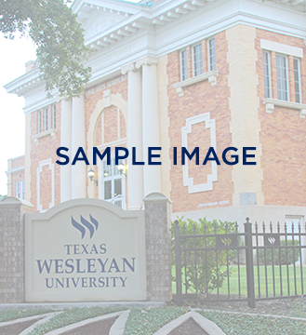

Sample Title Here

txwes.edu

More event details could go here if needed. More event details could go here if needed. More event details could go here if needed. More event details could go here if needed. More event details could go here if needed.

1201 Wesleyan Street | Fort Worth, Texas 76105   
817-531-4444 | info@txwes.edu

Event details  
August 21  
3:00 p.m. – 5:00 p.m.  
Location