

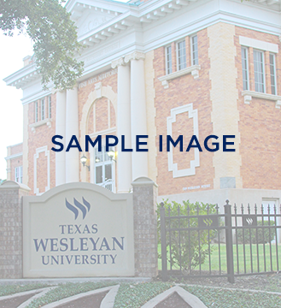
Questions? Contact us at
817-531-4444 or info@txwes.edu

Sample Title Here
Sample Title Here

Event details
August 21
3:00 p.m. – 5:00 p.m.
Location
More event details could go here if needed. More event details could go here if needed. More event details could go here if needed.

vvvvvvve

