

**Texas Wesleyan University Community Counseling Center**

TWUCCC

Clinic Handbook

Contents

Practicum Overview 3

Rules / Code of Conduct 4

Dress Code 5

Rooms 5

Ordering Materials 5

Front Desk 5

Being on Time 5

The Role of the Practicum Student 6

The Responsibility of the Practicum Student 8

Missing Appointments and Vacation 9

Procedures 10

Front Desk 10

Mentoring / Supervision 11

TheraNest / VALT 13

Scanning 13

Paperwork 17

Intakes 17

Minor Consent Paperwork 18

Release of Information 18

Attendance Reports 18

Time Limits on Paperwork 19

Writing SOAP Notes 19

TeleHealth Services 23

Section A

# Practicum Overview

The practicum student will participate in providing professional counseling and/or marriage and family therapy with individuals, couples, families, and/or groups at the TWUCCC. This practice experience provides an opportunity to develop and apply general, and in some cases specialized, counseling skills within a practical setting. The student will meet with the supervisor one hour each week for supervision.

**Goal:**

Students will demonstrate a comprehension of learned knowledge and be able to apply that knowledge to the practice of counseling preferably under the supervision of an LMFT, or LPC.

**Objectives:**

Once the internship is completed, the student will demonstrate the competencies of this program at a level of a beginning practitioner.

**Practicum Course Requirements:**

*All forms are found on each counseling degrees web page under the school of health professions. Once on the page, click the resources link to the left to find all the forms. They can be found on the TEAMS app under files.*

Students should have a preliminary meeting with their Advisor when reaching the practicum stage to ensure they are eligible to start.

1. Students must receive a written confirmation from the Practicum Director before the internship experience begins. This is the contract for hours. (Form 4/4A in Practicum Site Orientation Packet found on the counseling resources webpage and TEAMS)
2. Students must provide verification of malpractice insurance before they begin their practicum along with Form 5 Statement of Mutual Responsibilities.
3. Students must attend a Practicum orientation prior to beginning their Practicum experience.
4. Student must meet with Practicum Professor before seeing their first client when entering practicum I.
5. MFT Students must complete 350 clock hours of providing marriage and family therapy directly to clients during the Practicum experience and must attend in addition, one hour per week in supervisory session with their Approved Supervisor. The number of hours worked and the hour of supervision is to be documented each week on the “Practicum Activities Time Log” and signed by the student and Approved Supervisor at the end of each supervisory session.
   1. While pursuing the 350 hours of Practicum the student will engage with the Practicum Professor and peer students for one hour per week for mandatory weekly supervision.
6. Live data must be presented at least 3 times during practicum to the Practicum Professor as part of individual or group supervision.
7. All requirements and clinical paperwork must be completed in a satisfactory and timely manner to pass the course.

# Rules / Code of Conduct

## Dress Code

The dress code of the clinic is Business casual. With that in mind, you may want to join client’s children who sit on the floor during their session. Make sure you wear something appropriate such as Dress pants, Comfortable Polo Shirt are options for that session. Low-cut blouses or shorts will not be permitted otherwise.

## Rooms

Therapy rooms will be kept clean and orderly. There will be at least one pillow, clipboard, tissue box, and clock in each room. If you or your client use the last of an item in a room, please advise the person at the front desk or leave a note on the front desk to request more items.

If your client makes a mess, it is your responsibility to clean up before the next session.

Lounges and classrooms will be kept clean also. You may eat in these rooms, but clean up your area. If you spill something, cleaning supplies are located in the kitchen cabinets.

**Virtual Space**

Just like when you see a client face to face the area needs to be clean and orderly. Avoid doing session on your bed.

## Ordering Materials

Please contact the front office via face-to-face, phone call, or by email for any item/material request.

## Front Desk

While at the Front Desk, be mindful of what you say. When talking about a client issue make sure, the window is closed and talk at a low level.

You will have to sign up for a minimum of 4 hours to work the front desk each semester. Please See the Section “Front Desk” for additional info. In the drawer with the receipts, there is a commonly asked questions and directions paper.

We cannot transport clients nor travel to meet students on campus.

## Being on Time

Please be on time for all sessions. If you are going to be late, call or text the person at the front desk and notify your client with your best ETA.

In addition, sessions are 45-50 minutes long. Going overtime leaves no time to do notes. Being on time with your appointments stops the need to come in early on days off to do work.

If you are sick, email, call, or text the front office as soon as possible (817 531 4859). Please contact your client via TheraNest.

## The Role of the Practicum Student

Practicum students are to be compared to beginning level counselors/therapists. The practicum student has already developed and practiced many of the skills and competencies needed as a beginning level counselor. The students’ role is to begin assuming the professional responsibilities of a counselor under the careful supervision of trained staff. They are to function as an employee and comply with its policies and procedures.

The MFT practicum student is to conduct the 350 hours of direct face-to-face marriage and family therapy, with 150 of those hours being relational hours while enrolled in the Marriage and Family program.

The LPC practicum student is to conduct 150 direct hours for a total of 350 direct hours.

In addition, students must meet weekly with their Approved Supervisor, TWUCCC Director, Group Supervision and peer practicum students.

**Definitions of Types of Hours for Practicum Students**

In the MFT program, students are required to complete a total of 350 client contact hours by the end of their third Practicum semester of practicum, 350 need to be **direct** client contact hours (this can include relational, individual, co-therapy, group, reflecting teams) and a minimum of 150 of those must be relational hours, up to 50 of the total direct client contact hours should be telehealth hours**.**

In the PC program, students are required to complete a total of 350 client hours by the end of their second semester of practicum, where 150 are **direct** (75 per semester) and 200 are **indirect** (100 per semester)**.**

Direct Hours

* Direct client contact is face-to-face (therapist and client) therapeutic interventions. For purposes of this definition, face-to-face means meeting in the same physical location as the client or meeting through approved video-conferencing.

Indirect Hours

* Indirect hours are gained through activities such as case planning, record keeping, administrative activities, case consultation, travel to conferences, mentor/mentee hours, observing therapy (unless part of a team or part of an alternative hour), consultation with community members or professionals (CPS, doctors, hospitals), or continued education trainings and other professional development activities.

Telehealth Reflecting Teams

* **BEFORE** entering the “room” make sure to have your video off and your microphone muted.

Reflecting Teams

* Reflecting teams count as **direct** client contact hours because students observe a session and give feedback and participate in the interventions with a client through the therapist. PC students can acquire up to 50 of their direct client contact hours by participating in reflecting teams. MFT students can get up to 50 relational hours with a total of 100 of their direct client contact hours by doing reflecting teams.

Individual Client Hours

* Counseling individuals is done one on one with a therapist. Conducting session with individuals.

Relational Hours

* Relational hours are gained through meeting with more than one person in the therapy room. Family therapy, couple therapy, or other therapy with more than one person in the room are considered to be relational. Clients do not have to be biologically related this includes groups. Students in the MFT program must earn a total of 150 relational hours during their three practicum courses. The following are descriptions of clients that are considered “relational.”
* Family
  + People who consider themselves to be a family
    - Cohabitating members
    - A system composed of interdependent and interrelated parts.
      * Typically related (Sibling System, Parent/Child System)
      * A community or network in which one acts on and is affected by.
* Couple
  + Two people who identify as partners
    - Married couples, cohabitating couples, LGBTQ+ partners, etc.
    - Relation dyad, two or more people in a pre-existing relationship
* Family Group
  + A group of individuals who have lived together for a sufficient period of time for relational dynamics to be evident in their day-to-day interaction with one another, and in which these dynamics are addressed in therapy
  + People who consider themselves to be a family or couple in a processing or psychoeducational group
    - Parenting Group, Parent-Child Group, Parent-Adolescent Group
* Groups

For example, psychodynamic, grief, self-care, extra

Group Hours

* Group Therapy is done where a therapist oversees and facilitates a group with people who are not related to each other or do not consider themselves to be a family. Groups can be specific such as a psychoeducation group, anger management group, college student group, etc. These are considered individual groups. Students may also lead relational or family groups where individuals are related with each other.

Co-Therapy

* Co-therapy can occur when two therapists are present and work together in the same room at the same time with an individual, family, couple or group. Both therapists interact with the clients during the designated time. The co-therapist must be actively, continually, and regularly involved in the direct provision of treatment. Co-therapists assume significant responsibility for all aspects of the therapy case. When students are providing co-therapy, they must make time outside of supervision/therapy to discuss the case, complete paperwork, and plan for the next therapy sessions.

Supervision

* Minimum of 100 Hours during the practicum courses.
  + 1 hour a week group supervision with the practicum coordinator, Dr. Bishop
  + 3 hours a week of class supervision with the practicum teacher (13-16 weeks for the semester: 39-48 hours of total supervision for the semester)
  + 1 hour a week of supervision with an off-site supervisor if students have an internship or off site

Pre-Practicum

* + 2 Mentors
  + We don’t require direct client contact hours for PC Pre-Practicum students
  + We recommend that MFT Pre-Practicum students complete a minimum of 50 direct client contact hours in Pre-Practicum

## The Responsibility of the Practicum Student

• Accept responsibility for and ownership of their own learning process.

**• Acquire malpractice insurance as a practicum student for the entire period of the student practicum experience.**

• Actively seek to establish a positive, courteous and effective working relationship with the TWUCCC Director, Practicum Professor, and other staff of the Counseling Department as appropriate. This includes notification of cancellation at least 24 hours prior to appointments and meetings.

• Enter the TWUCCC and engage in professional relationships and change efforts in a manner that reflect a commitment to the ethics and values of the counseling profession, the mission, policies, procedures and protocols of the placement organization.

• Observe ethical practice for self-care regarding their work, placement and their own family obligations.

• Assure that the confidentiality rights of clients are protected at all times and in all circumstances.

• In response to varied client needs and requests, select from a repertoire of theories of intervention and conduct a variety of assessments, evaluations, interventions and treatments based on client goals and objectives.

• Complete practicum-learning assignments as required by the course syllabus.

• Complete required written work essential to effective performance in the TWUCCC.

• Prepare for and participate in weekly group case conference meetings with the Approved Supervisor and peers.

• Engage in on-going self-assessment, including a completion and review of the midterm and final evaluations.

* Inform the Approved Supervisor and the TWUCCC Director of potential problems and conflicts in a timely, written and appropriate manner in an attempt to ensure opportunity for discussion and problem solving at the earliest possible time.

## Missing Appointments and Vacation

You will be asked to put your schedule in TheraNest. You should not deviate from this. If you are available, you should be at the clinic or let the scheduler know where you are on campus so that they can call you if we have a crisis come in.

If you cannot make it because of some reason, you will need **to call your clients to reschedule**. **You should give your clients 24-hour notice just as you expect them to do.** The instance you know you will not make it in you need to let your clients know.

If you find you need to make contact after the center is closed, email the front office.

Typically, you get one week off for Christmas then another week off for vacation. While in school, you get around 4 weeks off for Christmas, 1 week of spring break, and one week at the end of the summer between Summer Extended and Fall Semesters where the TWUCCC is closed, which allows you time for a vacation. All other times you should be seeing clients and planning vacations around your clients and not clients around vacation.

Section B

# Procedures

## Front Desk

The main duty of the front desk position is to greet clients and have them fill out appropriate paperwork.

We have English paperwork, Spanish paperwork, and minor paperwork

If this is a reoccurring client, let that therapist know of their client’s arrival.

You will also be required to answer the phone, take a message, and if they want an appointment, record the following: **DO NOT SCHEDULE ANYBODY- JUST TAKE A MESSAGE.**

Name, phone number, Individual / Family / Couple / Good days/times

If the message is for a therapist, leave a message in TheraNest in the chat/IM feature.

You will also take payments. You must write the client’s first name and last initial, or client’s last name on the paper receipt if the client wants one.

**Watch for alarms to sound and help with crisis clients**.

When a button is pressed, an alarm is sounded. You will then need to check the room to see if the therapist needs security, MHMR, or if it is a false alarm.

**For a tornado alarm:**

Escort the people in the front office to the Lounge.

Go from room to room escorting people to classroom or the lounge.

If it is a false alarm, turn off the lights to let the therapists know it is safe.

**For a fire alarm:**

Have people in waiting room go outside and down to the corner of Wesleyan/Rosedale

All other rooms have notices what exit to use.

Make sure everyone has made it out and notify security if anyone is missing.

## Mentoring / Supervision

**Mentoring**

**Every** Pre-Practicum student must have *at least one mentor* and will need to fill out the “Mentor Form”.

Please remain in close contact with your mentor(s) throughout the semester. Do not wait until the end of the semester to fulfill your mentor requirements. Mentors may not be available and are not required to accommodate your schedule in the last 3 weeks of the semester.

**Supervision**

If you are seeing clients at the TWUCCC, you will need to attend supervision weekly.

Supervision is conducted 3-4 times a week with a designated faculty member. In lieu of group supervision, you may also meet with the TWUCCC Clinical Director for at least one hour a week.

Class counts as part of weekly supervision under Group Supervision for all 3 hours.

If you are a pre-practicum student and you are participating in co-therapy sessions, you must also attend Supervision for each week that you participate in sessions.

**PhD Supervision**

Doctoral students are required to hold supervision as part of their class requirements.

As a practicum intern, you may be asked to be part of their learning experience as well. Typically, they will post information in the lounge with their contact information in order to find people who work with their schedules in fulfilling the supervision roll of their class. These hours do not substitute for weekly group supervision, but DO count towards your overall supervision hours in order to graduate.

Doctoral Students may also observe your sessions and reflect with you about that particular session.

## TheraNest / VALT

Please see supporting Handbooks

## Scanning

When scanning and entering documents into TheraNest make sure, the scanner is turned on. Open the control center program located in the “Start” menu or in “All Programs” in the “Brother” folder. **\*\*\****Some computers show Control Center and some show Brother Utilities***\*\*\***

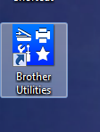 

Place document(s) facing up and the holes facing where they are to enter the machine.

**NOTE:** only scan 10 pages at a time since there is a 10MB limit per scan that can uploaded.

Once your papers are loaded in the scanner you will need to customize the scan so it will scan all the pages not one at a time.

To do this:

1. Click “Custom” then
2. Click “Custom Settings”

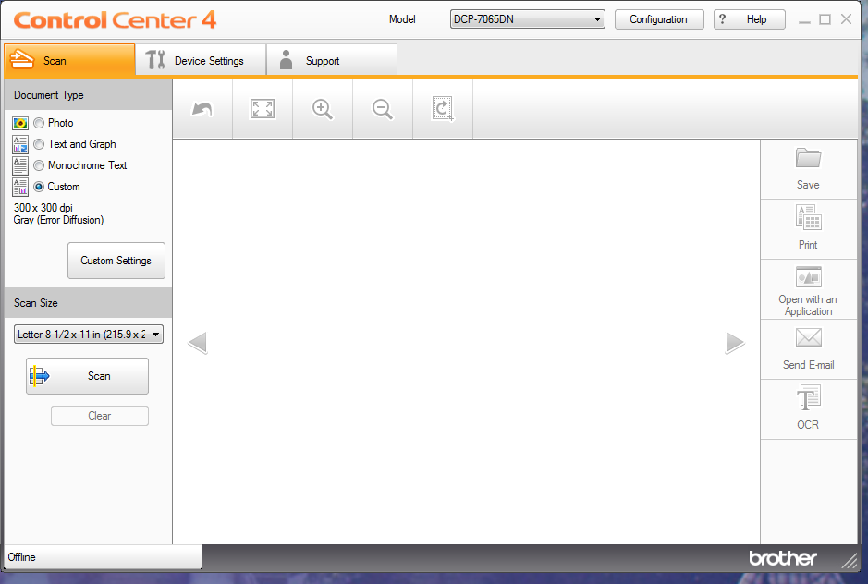

In the Custom Scan Settings, screen select “Continuous Scanning” to scan multiple pages. Once the 10th page is scanned, you will have the option to continue or finish. Click Finish if you are done scanning or click Continue if there are more items to be scanned.

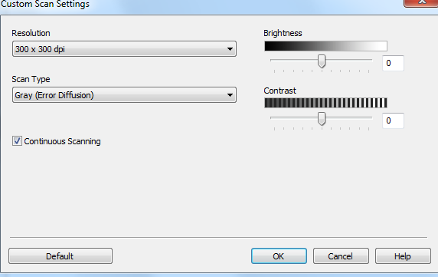

When you have completed scanning click “Save” this will open up the “Scan” folder. From here, you will drag and drop so keep the folder open. **NOTE:** Creating a short cut on the desktop is a good idea.

Once you have saved, click clear to scan your next document(s). 

**NOTE:** The pages below need to be scanned separately!

If there are **Birth Certificates, Legal Documents, Minor Consents, Attendance Reports**, or other special papers, please scan them individually so it is easier to find and edit if needed.

You can use client initials if you are scanning multiple clients folders so you can tell what scan belongs to whom. 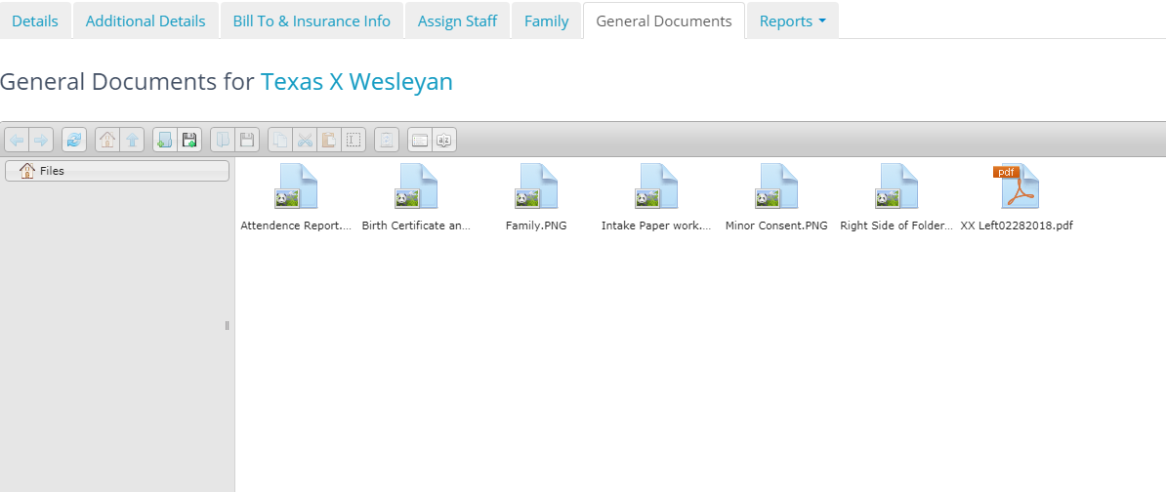

From the “Scan” folder, drag and drop the document(s) into the clients' record in TheraNest under the “General Documents” tab found in the clients’ profile. You are finished uploading the document(s) when you see it in the folder. Be sure to delete and empty the trashcan when you are finished.

Section C

# Paperwork

## Intakes

All intake paperwork is filled out on the first session. You will want to make sure they have signed where they need. After you go over the paperwork, you will need to sign the paperwork before you scan it.

At the end of the session, you will need to scan the information into the computer and enter the demographic information. Once scanned all information should go into the client’s document area in TheraNest and be shredded.

DO NOT TAKE THIS PAPERWORK OUT OF THE CLINIC

Do not leave the clinic for the day without scanning the documents into TheraNest.

If there is a minor present, you will need them to fill out the Minor Consent Paperwork

## Minor Consent Paperwork

If there is an actively participating person under the age of 18 in the session, you will need the Parent/Guardian fill out the paperwork.

On the paperwork, it will tell the person what we need to support that document.

Both Parents living together – Birth Certificate and ID

Divorced Parents – Divorce Decree – IDs

Appointment of Agent

For every client YOU MUST have one of the supporting documents and ALWAYS get a copy of their ID.

## Release of Information

Before you can talk to anyone, that is not a student or professor in the program about a client you **MUST** have the client fill out a release.

If a client, wants his/her own chart, or an attendance report you will need to fill out a release for every document. You will only need ONE release for the attendance report. Just scan the attendance report in TheraNest and reuse every time the client needs one.

If an outside agency has requested information, typically they will send a release. If the information is scanned it will be scanned into the clinical documents section for the client.

If you are requesting information from a doctor or outside agency, the client will need to fill out the release and give you the phone/scan number. After both of you have signed you can scan it to the person ONLY AFTER PERMISSION BY THE CLINCAL DIRECTOR IS GIVEN AND WITH THE RELEASE INCLUDED WITH WHAT WAS SENT IN THERANEST DOCUMENTS.

Never EVER let any information leave the center without the clients’ written & signed permission.

## Attendance Reports

These are used mostly for clients who are students and need an “excuse” for school.

Make sure they sign a release (Only once is needed)

Must be scanned into TheraNest after filled out and signed

Allows you to reuse it after each session

## Time Limits on Paperwork

*All completed in TheraNest*

Intake Paperwork

Must be signed and scanned **before** you leave for the day

Demographic information **must** be entered into TheraNest as well

Initial Assessment (Initial Assessments and Diagnostic Codes)

Must be completed no later than 24 hours after appointment

Progress Notes

Must be completed in TheraNest no later than 24 hours after session

Must be linked to an appointment.

Check Service Date vs. Creation Date

Will need to use pull down menu to select appointment

If others are present, make sure to put them as “Providers”

Treatment Plans

Must be completed by the 3rd session

**TWUCCC will be conducted Weekly**

*Documentation Deficiencies will be reported to your Practicum Instructor and/or the TWUCCC Clinical Director and may result in reduction of your professionalism grade, an increase in supervision, and limits on the addition of new client intakes.*

## Writing SOAP Notes

(taken (with additions) from *Learning to Write Case Notes Using the SOAP Format* –Susan Cameron and Imani turtle-song)

SOAP notes were developed in 1964 by L.L.Weed to enhance continuity of client care and assist in better recall/communication of details between and for the healthcare professional. Other case notes that are variations of the SOAP note model include:

DAP – Data, Assessment, Plan FOR – Functional Outcomes Reporting

**Using the SOAP Format**

The four components of SOAP notes are:

(S) subjective

(O) objective

(A) assessment

(P) plan

**S** – Subjective information about the presenting problem from the **client’s** perspective.

**O** – Objective information observed by the **counselor**.

**A** – Assessment that demonstrates how the S and O data is **formulated/interpreted/reflected**

**upon**.

**P** – plan summarizing of the **direction of treatment**.

**Subjective**

This section can be the most troublesome. Here the client’s feelings, goals and thoughts as well as the intensity of the problem and how it may affect significant other(s) are recorded. The entry should be as **brief and concise** as possible without the overuse of quotations since at the end of a session, research shows that it is unlikely to accurately

remember verbatim information. If, however quotations are used, only key words or phrases should be recorded. For example, this might include a suicidal or homicidal

ideation, unwillingness to provide necessary information, inappropriately aggressive or abusive language that the counselor may deem threatening.

*For instance, a father accused of shaking his 6-month-old daughter*

*when she would not stop crying says, “I only scared her when I*

*shook her, I didn’t hurt her.”*

*The counselor might write: “Minimizes the effects of shaking infant*

*daughter. States, “I only scared her.”* ***Use only a minimum of quotes***

Ways to write briefly, **yet concisely:**

*The client may say, “Therapy is really helping me put my life into*

*perspective,” (10 words), could be written “Reports therapy is really helping.”*

*(Five words)*

Rather than using names of specific people’s names, use general terms as “fellow employee” or “mental health worker”, and briefly report the **themes** of the client’s complaint.

The content of the **S** section belong to the client. For brevity’s sakes, the counselor

should write, “reports, states, says, describes, indicates, complains of.

For example, instead of writing, “Today the client says, ‘I am experiencing

much more marital trouble since the time before our last session’ (14 words),

the counselor might write, “Client reports increased marital problem since

last session.” (8 words).

**Objective**

This information should be factual and in quantifiable terms – that which can be seen,

heard, smelled, counted or measured. Avoid words such as “appeared” or “seemed”

without objective supporting evidence. Avoid labels, personal judgments, opinionated

statements. Words that carry a negative connotation such as, “uncooperative”, “manipulative,” “abusive,” “obnoxious,” “spoiled,” “dysfunctional,” and “drunk.” These

words are open to personal interpretation. The most helpful phrase is, “as evidenced by.”

For example, “Appeared depressed, as evidenced by significantly

less verbal exchange; intermittent difficulty tracking. Hair uncombed,

clothes unkept. Denies feeling depressed.”

Simply record what is seen, heard, or smelled.

For example, “Client smelled of alcohol; speech slow and deliberate

in nature; uncontrollable giggles even after stumbling against door

jam; unsteady gait.”

**Assessment**

This section summarizes the counselor’s **clinical thinking.** Clinical impressions may also be used to “rule out” or “rule in” a diagnosis. Clinical impressions also enable viewers to follow the counselor’s reasoning and direction for treatment. When making

a diagnostic impression, ask the question, “Is there adequate/sufficient data here to support a clinical diagnosis?” If sufficient data has been collected, the **S** and **O** sections should reasonably support the diagnosis. If, however, there is ambivalence in making

a diagnosis this might suggest insufficient data has been collected or that a consultation with a senior colleague is in order.

**Plan**

This section describes the parameters of the intervention. It consists generally of two parts, the action plan and the prognosis. It may include a referral to an agency or some other form of

intervention. The prognosis is a forecast of the probable gains to be made by the plan.

**Scenario**

Cecil is a 34-year-old man who was mandated by the courts to obtain counseling to resolve his problems with domestic violence. He comes into the office, slams the door, and announces in a loud and irritated voice, “This counseling stuff is crap! There’s no

Parking! My wife and kids are gone! And I gotta pay for something that don’t work!”

Through most of the counseling session, Cecil remains agitated. Speaking in an angry and aggressive voice, he tells you that his probation officer told him he was a good man and could get his wife and kids back. He demands to know why you are not really helping him get back what is the most important to him. He insists that, “Mary just screws everything up?” He goes on to tell you of a violent argument he and Mary had last night regarding the privileges of their daughter Nicole, who just turned 16. You are aware that there is a restraining order against Cecil.

During the session, you learn Cecil was raised in a physically and verbally abuse family until he was 11, at which time he was placed in protective custody by social services, where he remained until he was18. He goes on to tell you that he has been arrested numerous times for “brawling” and reports that sometimes the littlest things make him angry and he just explodes, hitting whatever is available – the walls, his wife, the kids, and three guys at work. Cecil also reports prior arrests for domestic violence. He admits that at various time, he has been both physical and emotionally abusive to Mary and the children but insists that it was needed to “straighten them out.” Just before leaving your office, Cecil rushes from his chair and stands within a foot of you. Angrily, with his fist and jaw clenched, he says, “This is the same old B.S. You guys are just all talk.” He storms from the room.

**Sample SOAP note (using abbreviations and *meanings* not put in above notes)**

**S:** Reports cslng (counseling) not helpful in getting family back. Insists on violence to “straighten out” family. Reports hx (history) of DV(Domestic violence). States verbally fought ĉ (with) wife over oldest child’s privileges. Clt. or C (circled) reported personal physical and mental abuse as child resulting foster care placement, ages 8-11.

**O:** Generally agitated in session as evidenced by clenched fist and jaw. Near end of

session, clt or C(circled) stated counseling is “same old B.S!” Rushed out of office.

**A:** Physical abuse as adult and child.

**P:** Prognosis guarded due to ¯(decreases or low) level of motivation to change. Will continue __________therapy. Possible referral to Dr. ___________ for psych. (psychiatric) eval.(evaluation) and Men’s Alternative Violence Group. Next session, introduce use of “time outs.”

Section D

# TeleHealth Services

**25-minute introduction to Telemental Health :**

(“Dr. Bartee’s Video”) <https://youtu.be/tRfJK-WAtg0>

**TELEFLECTING GUIDELINES**

We would like to implement the new teleflecting team policy for teletherapy reflecting teams. We are always striving to improve our programs, and to provide the best educational opportunities possible. We greatly appreciate your feedback in making it happen. We hope that the guidelines below will help provide some clarity. If done well, teletherapy-reflecting teams can be therapeutically beneficial to the client, and can be a good learning experience for all involved. Tele ’teams should be considered a supplemental learning experience, and should not be used as a way to accrue hours in lieu of working directly with clients. In order to develop your clinical skills and grow as a clinician, you have to practice. Take advantage of the opportunity to practice and learn in an environment where you have support.

* **Teletherapy Reflecting Team (Teleflecting) Guidelines:**  When – **BEFORE** entering the “room” make sure your camera is off and your microphone is muted.
* **Therapists should leave about 5 - 10 min.** during the session to consult with their teletherapy reflecting team. The flow of every session is a bit different; use your clinical judgement to determine when you can ask the clients to take 5 min break to consult with your tele’ team. It is a good idea to set a general timeline for the teleflecting team and then adjust as necessary. This way your client knows what to expect. (Approximately 30 to 40 minutes after the hour is a good rule of thumb). How Long – Teleflecting team consultation should last approximately 5 minutes, and no more than 10 minutes. If it works with the flow of the session, it can be a good idea to leave your client(s) with a question or something to think about while you consult with the team. This can make the time you will be out of the teletherapy session more productive for the client(s). Place the client in a breakout room while you conduct your reflection. You can consult with your colleagues who are online in the same teletherapy session with you during this time. Ask your colleagues to share with you their notes using the share tool online (every platform usually has a share document tool) or they can share their notes by writing these in the chat box. Discuss with your colleagues their online feedback. Let them enable their microphones one at a time. Every student will be able to make one or two comments. Be mindful of the time! You have only about 5 to 10min for this process.
* **Role of the Primary Therapist** – Take charge of the reflecting team experience! As the primary therapist in the reflecting team experience, it is your responsibility to set a goal for what you hope to accomplish with the reflecting team. For example: “I would like you to pay attention to the mother and daughter dynamic. “Go into the reflecting team consultation with a plan, and let the team know exactly how they can help you. If you can consult with the team prior to the session, and let them know your goal, this is preferable but not necessary. Remember - the feedback you receive is something to think about, and not necessarily something, that has to be applied (especially during that session). You are the one who ultimately decides! The primary therapist may ask the clients toward the end of the session to comment on what was most notable for them as they listened to the reflecting team discussion. For example:” What stood out for you from the reflecting team’s comments?”
* **Role of the Reflecting Team** – Observe the entire session. It may be helpful for everyone to take notes, and then use the online share tool to share all the feedback. Be encouraging and supportive. Be aware that the therapist might be feeling overwhelmed or anxious. Put yourself in their shoes and think about what might be helpful to you in that situation. Use the statement, “I noticed…. And I wonder….” Keep it short and simple. Use curiosity to express areas of exploration, “I wonder…”
* For example: “I notice this couple is able to express love even though they have areas of strong disagreement,” “I wonder how they were able to do this?” “I noticed this family’s ability to see through their son’s stealing behavior—to see his strengths!” “I wonder how they could do this on regular basis.”
* “I wonder what the family might say if the therapist explored exceptions to the problem,” “I wonder how the family might respond if the therapist externalized the problem,” or “I am curious if the teenager might be more engaged if the therapist reframed the issue for the family, in terms of the son protecting his siblings versus being bossy.”

**Telehealth Frequently Asked Questions**

**A. Concerns about Telehealth**

1. **What is the liability of practicum interns conducting telehealth from their homes?**

The liability is the same as in the clinic.

1. **What new procedures will practicum need to be trained on for our new teletherapy format?**

**Watch this video Introduction to Doing Teletherapy Webinar:** [https://youtu.be/gIGXYr-r3Q](https://youtu.be/g-IGXYr-r3Q)

**B. How are we…?**

1. **Participating in Group Supervision**

**Group Supervision will be held with the designated supervisor 3 times a week.** Please email Clinical Director for the dates and times each semester. Those providing services through our Clinic will be required to attend one of these sessions each week they have contact with a clinic client.

1. **Recording sessions**

Sessions are to be scheduled and recorded with your TEAMS channel provided by the clinical office manager.

1. **Observing sessions for supervision**

Please contact your practicum professor for other options.

1. **Contacting practicum professors and/ or supervisors in a crisis situation**

Please contact your practicum professor for a detailed safety plan. *(Refer to Process Handout)*

**C. Client Care**

1. **When can we start video sessions/phone therapy?**

(**Introduction to Doing Teletherapy Webinar:** <https://youtu.be/g-IGXYr-r3Q>). When your instructor approves your readiness to do technology-assisted therapy, you may begin your telehealth sessions.

1. **Do we have to use video sessions, or can we offer other forms of telehealth?**

Video sessions are the only approved forms of conducting telehealth.

1. **Can we conduct well checks for clients that do not want to participate in video sessions?**

No

1. **How do we chart Teletherapy?**

When conducting telehealth, chart requirements are the same as when conducting in person sessions (**demographics, initial assessment**, and **progress notes**, with the addition of **contact logs** and the new **teletherapy procedures**.

1. **Is it mandatory for me to participate in this process if I do not need hours?**

**YES**, All practicum students are required to collect telehealth hours. **Graduating practicum interns are still responsible for client care until the transfer process is complete**.

1. **How do I Transfer Clients?**

**Inform the client** of the transfer process, **select** and **communicate** with the **transfer therapist** (contact the CCC for a list), **conduct co-therapy** video sessions (min. 2), confirm that **all documentation is up to date**. Make sure you close out your case (In the **notes section** under **cases**). The new therapist should open up their own **case note** in this section that way they can complete their own new **initial assessment**, **treatment plan**, and **first progress note**. If there is not a new therapist because the client is ending therapy, please **close the case** and **archive** the client.

1. **Can I schedule appointments for any time of the day?**

Do not schedule on the half-hour as this blocks the room for 2 hours making it difficult for others to schedule, especially on the busier days/ nights. Please be mindful of both clinic hours (M-Th. 9-8 Closed on Fri. and Sat. 10-2) and your personal hours (school and work schedule).

1. **How do I handle an intake with an individual from the client information task sheet?**

All intake sessions MUST be in person to review and sign paperwork and prepay for future sessions. All intake documentation is still required for teletherapy, including informed consent. Obtain and/or verify **client email address (input information in client details)**, **send client the link and** **schedule** appointment, *intake forms must be completed before first session*, conduct first session as an intake (informed consent) and include **teletherapy procedures**. Again, *Intake paperwork must be obtained to conduct the first session, all documentation requirements are still mandatory for teletherapy.*

1. **How do I handle clients with CPS cases and other legal matters?**

WE DO NOT Perform “Forensic services” (child custody, disability, claims, assessment for legal purposes, psychological evaluation) and CANNOT provide forensic opinions, reports, assessments, or recommendations according to Rule 465.18, Texas Administrative Code Title 22.

1. **What are the time limits on documentation?**

**Initial Assessment and Diagnostic Codes      Day of Treatment (No later than 24 hours after first session)**

**Progress Notes                                               Day of treatment (No later than 24 hrs. after session)**

**Treatment Plan                                                By Third session and updated every 3rd session**

**Contact Log Immediately following EACH communication exchange with client**

1. **Who will be tracking my documentation?**

The Clinical Director will conduct **WEEKLY AUDITS.** And report them to your practicum instructor.

**Helpful Links and Resources**

**Introduction to Doing Teletherapy Webinar:** <https://youtu.be/g-IGXYr-r3Q>

**Breathing through Anxiety -** 4-7-8 breathing technique that consists of taking a deep breath for a count of four, holding the breath for seven counts, and exhaling for eight counts. This sequence is then repeated four times and can be used as often as necessary (Weil, 2011).

**MHMR 24/7 ICARE Call Center**

817 335 3022 (call or text)

1 800 866 2465 (toll free)

**Suicide and Crisis Center of North Texas**

988

Text GO to 741741 Text Crisis 24 hr. Line Confidential

**Hearing Impaired**

1 800 799 4889

**JPS Psychiatric Emergency**

817 702 4151

**Spanish Crisis Line Mental Health America**

1 888 628 9454

**TXWES SPECIFIC RESOURCES**

<https://txwes.edu/>

<https://txwes.edu/stress/>

**TimlyCare**

[timelycare.com/txwes](https://app.timelycare.com/auth/login)

Instagram: @timelycare

Twitter: @timely_care

TikTok: @timelycare